Magaud, H. (2003) Water quality – Guidance document on the statistical analysis of ecotoxicity data. ISO TC 147/ SC 5/ WG 10/ N 0390

Chapter 7: Biology-based methods
Kooijman, S. A. L. M., Bedaux, J. J. M, Péry, A. R. R. & Jager, T.

7.1 Introduction

7.1.1 Effects as functions of concentration and exposure time
Biology-based methods not only aim to describe observed effects, but also to understand them in terms of underlying processes such as toxicokinetics, mortality, feeding, growth and reproduction (Kooijman 1997). This focus on dynamic aspects makes that exposure time is treated explicitly.

This chapter focuses on the analysis of data from a number of standardized bioassays on mortality, body growth (e.g. fish), reproduction (e.g. daphnia), steady-state population growth (of e.g. algae, duckweed). The guidelines for these bioassays prescribe that background mortality is small, while the duration of the bioassays is short relative to the life-span of the test-organisms. Moreover the tests are done under conditions that are otherwise optimal, which excludes multiple stressors (e.g. effects of food restriction, temperature (Heugens, 2001, 2003)), and quite a few processes that are active under field conditions (e.g. adaptation, population dynamics, species interactions, life-cycle phenomena (Sibly and Calow (1989)). The type of data that are routinely collected in these bioassays are very much limited, and do not include internal concentrations of test compounds. These restrictions exclude the application of quite a few potentially useful methods and models for data analysis, such as more advanced pharmacokinetic models and time series analysis, see e.g Newman (1995). The theory behind biology-based methods can deal with dynamic environments (changing concentrations of test compounds, changing food densities), but the application in the analysis of results from bioassays is simplified by the assumption that organisms’ local environment in bioassays is constant.

Biology-based methods make use of prior knowledge about the chemistry and biology behind the observed effects. This knowledge is used to specify a response surface, i.e. the effects as a function of the (constant) concentration of test compound in the medium and the exposure time to the test compound. This response surface is determined by a number of parameters. The first step is to estimate these parameters from data. The second step is to use these parameter values to calculate quantities of interest, such as the ECx-time curve, or the confidence interval of the No-Effect-Concentration (NEC). It is also possible to use these parameter values to predict effects at longer exposure times, or effects when the concentration in the medium is not constant. If the observed effects include those on survival and reproduction of individuals, these parameters can also be used to predict effects on growing populations (in the field) (Kooijman 1985, 1988, 1997, Hallam et al 1989).

It is essential to realise that ECx values decrease for increasing exposure time, as long as the exposure concentration and the organism’s sensitivity remain constant. This is partly due to the fact that effects depend on internal concentrations (Kooijman 1981, Gerritsen 1997, Péry et al 2001a), and that it takes time for the compound to penetrate the body of test organisms. (The standard is to start with organisms that were not previously exposed to the compound.) The exposure period during which the decrease is substantial depends on the properties of the test compound and of the organism and the type of effect. For test compounds with large octanol-water partition coefficients and test organisms with large body sizes this period is usually large. The LC50 for daphnids hardly decreases for a surfactant after two days, for instance, but their LC50 for cadmium still decreases substantially after three weeks. For this reason, biology-based methods fit a response surface to data, using all observation times simultaneously. If just a single observation time is available, however, these methods can still be used and the response surface reduces to a response curve. Obviously, such data hardly contain information about the dynamic aspect of the occurrence of effects. The parameter(s) that quantify this aspect are then likely to be poorly defined. This does not need to be problematic for all applications (such as the interpolation of responses for other concentrations at that particular observation time; this is the job of dose-response methods). It is strongly recommended, however, for a two-day test on survival, for instance, to use not only the counts at the end of the experiment, but also those at one day. Such data are usually available (and GLP even requires to report those data), but these data are not always used. More recommendations are given in section 7.3.

In practice it is not unusual that very few, if any, concentrations exist with partial effects; survival tends to be of the “all or nothing” type in most concentrations. High concentrations run out of surviving individuals more rapidly than lower concentrations. This can occur in ways such that for each single observation time no, or very few, concentrations show partial mortality. This situation also occurs if each individual is exposed separately, and measured rather than nominal concentrations are used in the data analysis; one then has just a single individual per concentration. Although such a case is generally problematic for dose-response methods, because a free slope parameter has to be estimated (Kooijman 1983), biology-based methods do not suffer from this problem, because the (maximum) slope is not a free parameter (models’ slope of concentration-survival curves increases during exposure), and the information of the complete response surface is used. An example will be given in section 7.3

Biology-based methods allow the use of several data sets simultaneously, such as survival data, sublethal effect data, and data on the concentration of test compound inside the bodies of the test organisms during accumulation/elimination experiments. As will be discussed below, logical relationships exist between those data, and these relationships can be used to acquire information about the value of particular parameters that occur in all these data sets. Both the statistical procedures and the computations can become somewhat more complex in this type of advanced applications, but free and downloadable software exist that can do all computations with minimum effort (see below).

Parameter estimation
The maximum likelihood (ML) method is used to estimate parameter values (the criterion of least squared deviations between data and model predictions is a special case of the ML method, where the scatter is independently normally distributed with a constant variance). If more than one data set is used (for instance, data on body size and reproduction rate and/or internal concentration), the assumption is that the stochastic deviations from the mean are independent for the different data sets. This allows the formulation of a composite likelihood function that contains all parameters for all models that are used to describe the available data sets. For effects on survival, the number of dead individuals between subsequent observation times follows a multinomial distribution (see e.g. Morgan 1992); for sublethal effects, the deviations from the mean are assumed to be independently normally distributed with a common (data-set-specific) variance. The deterministic part of the model prediction is fully specified by the theory, for the stochastic part, only these straightforward assumptions are programmed in the DEBtox software (see Section 7.9.). The software package DEBtool, allows more flexibility in the stochastic model, e.g. for ML estimates in the case that the variance is proportional to the squared mean; this rarely results in substantially different estimates, however.)

If surviving individuals are counted in a bioassay and tissue-concentrations are measured in another bioassay, a composite likelihood function can be constructed that combines these multinomial and normal distributions. The elimination rate (dimension: per time) is a parameter that occurs in both types of data; in survival data it quantifies how long it takes for death to show up; if the elimination rate is high, one only has to wait a short time to see the ultimate effects. The elimination rate can, therefore, be extracted from survival data in absence of data on internal concentrations. Although it is helpful to have the concentration-in-tissue data (both for estimating the parameters and for testing model assumptions), these data are by no means required to analyse effects on survival. If one has prior knowledge about the value of the elimination rate, one can fix this parameter and estimate the other parameters (such as the NEC) from survival data.

Profile likelihood functions are used to obtain confidence intervals for parameters of special interest, and in particular for the NEC. This way of quantification of the uncertainty in a parameter value does not necessarily lead to a single compact interval, but sometimes leads to two, non-overlapping intervals. Therefore, they can better be indicated with the term “confidence set”. Computer simulation studies have shown that these confidence sets are valid for extremely low numbers of concentrations and of test organisms (Andersen et al, 2000).
Estimation procedures have been worked out (Kooijman 1983) to handle somewhat more complex experimental designs, in which living individuals are sacrificed for tissue analysis during bioassays. The information that they were still living at the moment of sampling is taken into account in the estimation of parameter values that quantify the toxicity of the compound. Péry et al (2001) discuss the estimation of parameters in the case that the concentration in the media varies in time using hazard models; Kooijman (1981) and Reinert et al (2002) use critical body residue models.

Outlook
This document only discusses the simplest experimental designs of bioassays and the simplest models. The authors of this document are unaware of alternatives models in the open literature that are applicable on a routine basis and hope that this document will stimulate research into this direction. The models can be and has been extended in many different ways; just one example is given. All individuals are assumed to have identical parameter values in the models that are discussed below. Individuals can differ, despite the standardisation efforts in bioassays. Such difference might relate to differences in one or more parameter values (Sprague 1995). It is mathematically not difficult to include such differences in the analysis, on the basis of assumptions about the simultaneous scatter distribution of the parameter values. Needless to say, one really does know little if anything about this distribution. This makes that such assumptions must be inspired by convenience arguments rather than by mechanistic insight. A strong argument for refraining from such extensions is that the method becomes highly unpractical. The data simply do not allow a substantial increase in the number of parameters that must be estimated from routine data.

The theory covers many features, such as extrapolating from constant to pulse exposures and vice versa, and including the effects of senescence, that are not yet worked out in software support (see Section 7.9).

The modules of effect-models
Effects are described on the basis of a sequence of three steps (modules):
- Change in the internal concentration: the step from a concentration in the local environment (here the medium that is used in the bioassay) to the concentration in the test organism.
- Change in a physiological target parameter: the step from a concentration in the test organism to a change in a target parameter, such as the hazard rate, the (maximum) assimilation rate, the specific maintenance rate, the energy costs per offspring, etc.
3) Change in an endpoint: the step from a change in a target parameter to a change in an endpoint, such as the reproduction rate, the total number of offspring during an exposure period, etc.

This decomposition of the description of effects into three modules calls for an eco-physiological model of the test organism that reveals all possible physiological targets. The primary interest is in small effects. A simplifying assumption is that just a single physiological process is affected at low concentrations and that this effect can be described by a single parameter. At higher concentrations, more processes might be affected simultaneously. This means that the number of possible effects (and so the number of required parameters) can rapidly increase for large effects. It is unpractical and, for our purpose not necessary, to try to describe large effects in detail.

The concept “most sensitive physiological process” has an intimate link with the concept “no-effect-concentration”. The general idea is that each physiological process has its own “no-effect-concentration”, and that these concentrations can be ordered. Below the lowest no-effect-concentration, the compound has no effect on the organism as a whole. Between the lowest and the second lowest no-effect concentrations, a single physiological process is affected; between the second and the third lowest no-effect concentrations, two processes are affected, etc.

The concept “no-effect-concentration” is quite natural in eco-physiology (see e.g. Chen & Selleck 1969). All methods for the analysis of toxicity data (including hypothesis testing and dose-response methods) make use of the concept “no-effect-concentration”. All methods assume, at least implicitly, that compounds in the medium, apart from the tested chemical, do not affect the organism’s response. Hypothesis testing explicitly assumes that the tested chemical has no effect at the response at concentrations equal to, and lower than, the NOEC. Biology-based methods use the NEC as free parameter.

Generally each compound has three domains in concentration:
- Effects due to shortage. Think, for instance, of elemental copper, which is required in trace amounts for several co-enzymes of most species
- No-effect range. The physiological performance of the organism seems to be independent of the concentration, provided that it remains in the no-effect range. Think, for instance, of the concentration of nitrate in phosphate limited algal populations; Liebig’s famous minimum law rests on the “no-effect” concept (von Liebig 1840)
- Toxic effects. Think, for instance, of glucose, which is a nutritious substrate for most bacteria in low concentrations, but inhibits growth if the concentration is as high as in jam.

It is essential to realise that the judgement “no-effect” is specific for the level of organisation under consideration. At the molecular level, molecules cannot be classified into one type that does not give effects, and another type that gives effects. The response of the individual as a whole is involved (Elsasser 1998). The concept “no-effect-concentration” can deal with the situation that it is possible to remove a kidney, for instance, from a human subject (so a clear effect at the sub-organism-level), without any obvious adverse effects at the level of the individual (during the limited time of a bioassay). This example, therefore, shows that below the NEC effects can occur at the suborganismic level (e.g. enzyme induction), as well as on other endpoints that are not included in the analysis (e.g. changes in behaviour).

Most compounds are not required for the organisms’ physiology, which means that their range of concentrations that cause effects due to shortage is zero, and the lower bound of the no-effect range is, therefore, zero as well. Some compounds, and especially the genotoxic ones (van der Hoeven et al 1990, de Raat et al 1985, 1987, Purchase & Auton 1995), are likely to have a no-effect range of zero as well, and the upper bound of the no-effect range is, therefore, also zero. This gives no theoretical problems in biology-based methods. A NEC of zero is just a special case, and a point estimate for this concentration from effect-data should (ideally) not deviate significantly from zero (apart from the Type I error ; a Type I error occurs if the null hypothesis is rejected, while it is true).

The model for each of the three modules for the description of effects is kept as simple as possible for practical reasons, where one usually has very little, if any, information about internal concentrations, or physiological responses of the test organisms. Each of these modules can be replaced by more realistic (and more complex) modules if adequate information is available. Some applications allow further simplification. Algal cells, for instance, are so small that the intracellular concentration can be safely assumed to be in instantaneous equilibrium with the concentration in the media that are used in the bioassay for growth inhibition. This gives a constant ratio between the internal and external concentrations, and simplifies the model considerably. The standard modules are introduced below.

Toxico-kinetics model
The toxico-kinetic module is taken to be a first order kinetics by default; the accumulation flux is proportional to the concentration in the local environment, and the elimination flux is proportional to the concentration inside the organism. This simple two-parameter model is rarely accurate in detail, but frequently captures the main features of toxico-kinetics (Harding & Vass 1979, Kimerle et al 1981, McLeese et al 1979, Spacie & Hamelink 1979, Wang et al 1981, Janssen et al 1991, Legierse et al 1998, Jager, 2003, Jaget et al 2003). It can be replaced by a more-compartment model, or a pharmacokinetic model, if there are sound reasons for this. Metabolic transformation, and satiation in the elimination rate can modify toxico-kinetics in ways that are sometimes simple to model (Kooijman 2000).

If the organism grows during exposure, or changes in lipid content occur (for instance when the test organisms are starved during exposure), predictable deviations from first order kinetics can be expected, and taken into account (Kooijman & van Haren 1990, Kooijman 2000). Dilution by growth should always be taken into account in the bioassays for body growth and reproduction, since such a dilution affects the effect-time profiles substantially.

Physiological targets of toxicants
The specification of sublethal effects involves an eco-physiological model that reveals all potential target parameters, and allows the evaluation of the endpoints of interest. A popular endpoint is, for instance, the cumulative number of offspring of female daphnids in a three-weeks period. The model should specify such a number, as well as the various physiological routes that lead to a change of this number. It should also be not too complex for practical application. An example of such a model is the Dynamic Energy Budget (DEB) model. Because it is the only model for which generic applications in the analysis of toxicity data has been worked out presently, the following discussion will focus on this model.

The DEB model results from a theory that is described conceptually in Kooijman (2001) and Nisbet et al (2000), and discussed in detail in Kooijman (2000). Figure 7.1 gives a scheme of fluxes of material through an animal, which are specified mathematically in the DEB model, on the basis of mechanistic assumptions. The model’s main features are indicated in the legend of Figure 7.1. The DEB theory is not confined to animals, however, and covers all forms of life.
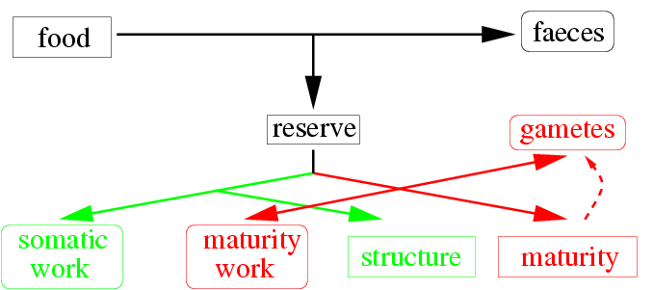
Figure 7.1 Fluxes of material and energy through an animal, as specified in the DEB model. Assimilation, i.e. the conversion of food into reserve (plus faeces) is proportional to structure’s surface area. Somatic and maturity work (involved in maintenance) are linked to structure’s mass, but some components (heating in birds and mammals, osmo-regulation in freshwater organisms) are linked to structure’s surface area. Allocation to structure is known as growth; to maturity as development; to gametes as reproduction. Embryos do not feed, juveniles do not reproduce, adults do not develop. Reserves and structure are both conceived as mixtures of mainly proteins, carbohydrates and lipids; they can differ in composition. The rate of use of reserve depends on the amount of reserve and structure; this rate is known as the catabolic rate. A fixed fraction of the catabolic flux is allocated to somatic maintenance plus growth, as opposed to maturity maintenance plus development (or reproduction).

The general philosophy behind the DEB theory is a full balance approach for food (nutrients, energy, etc): “what goes in must come out”. Offspring is (indirectly) produced from food, which relates reproduction to feeding. Large individuals eat more than small ones, which links feeding to growth. Maintenance represents a drain of resources that is not linked to net synthesis of tissue or to reproduction. An increase of maintenance, therefore, indirectly leads to a reduction of growth, so to a reduction of feeding and reproduction.

This reasoning shows that the model requires a minimum level of complexity to address the various modes of action of a compound. One needs to identify this route to translate effects on individuals to that on the growth of natural populations (in the field). If food conditions are good, investment into maintenance, for instance, comprises only a small fraction of the daily food budget of individuals. Small effects of a toxicant on maintenance, therefore, result in very small effects on the population growth rate. If food conditions are poor, however, maintenance comprises a large fraction of the daily food budget. Small effects on maintenance can now translate into substantial effects on the population size. This reasoning shows that effects on populations depend on food conditions, which generally vary in time (Kooijman 1985, 1988, Hallam et al 1989). The different modes of action usually result in very similar point estimates for the NEC, within the current experience. Furthermore, no effects on individuals implies no effects on populations of individuals, but the mode of action is particularly important for predicting the effects at the population level.

Change in target parameter
The value of the target parameter is assumed to be linear in the internal concentration. The argumentation for this very simple relationship is in the theorem by Taylor, which states that any regular function can be approximated with any degree of accuracy for a limited domain by a polynomial of sufficiently large order. The interest is usually in small effects only, and routine applicability urges for maximum simplicity, so a first order polynomial (i.e. a linear relationship) is a strategic choice.

The biological mechanism of a linear relationship between the parameter value and internal concentration boils down to the independent action at the molecular level. Each molecule that exceeds individual’s capacity to repress effects acts independent of the other molecules. Think of the analogy where photosynthesis of a tree is just proportional to the number of leaves as long as this number is small; as soon as the number grows large, self-shading occurs and photosynthesis is likely to be less than predicted.

We doubtlessly require non-linear responses for larger effect levels, but then also need to include more types of effects. Interesting extensions include receptor-mediated effects. The biochemistry of receptors is rather complex. Two popular models are frequently used to model receptor-mediated effects and concentration: the Michaelis Menten model boils down to a hyperbolic relationship, rather than a linear one (which has one parameter more, Muller & Nisbet (1997)); the Hill model boils down to a log-logistic relationship (and has two parameters more than the linear model, Hill (1910), Garric et al (1990), Vindimian et al (1983)). Such extensions are particularly interesting if toxicokinetics is fast, and the internal concentration is proportional to the external one (such as in cell cultures). The assumption that the target parameter is linear in the internal concentration does not translate into a linear response of the endpoint; it usually translates into sigmoid concentration-endpoint relationships, which are well known from empirical results. Notice that the linear model is a special case of the hyperbolic one, which is a special case of the log-logistic one.

Change in endpoint
The DEB model specifies how changes in one or more target parameters translate into changes in a specified endpoint. Popular choices for endpoints are reproduction rates (number of offspring per time), cumulative number of offspring (in daphnia-reproduction bioassays), body length (in fish-growth bioassays) and survival probability. Survival and reproduction together determine steady state population growth, if they are known for all ages. Reproduction rates depend on age, namely, and the first few offspring contribute much more to population growth than later offspring. This is a consequence of the principle of interest-upon-interest; early offspring start reproduction earlier than later offspring. As will be discussed below, indirect effects on reproduction come with a delay of the onset of reproduction, while direct effects on reproduction do not. The DEB model takes care of this more complex, but important, aspects of reproduction. Given the DEB model, there is no need to study all ages of the test organism once the DEB parameters are known. This application requires some basic eco-physiological knowledge about the species of test organism, but the acquisition of this knowledge does not have to be repeated for each toxicity bioassay.

Survival
The effects on the survival probability of individuals are specified via the hazard rate. A hazard rate (dimension: probability per time) is also known as the instantaneous death rate. The hazard rate h(t) relates to the survival probability q(t) as
$h(t)=−q(t)^{−1}\frac{d}{\text{dt}}q(t)$ or $q(t)=\text{exp}\left\{−\int{h(s)\text{ds}}\right\}$
The product $h$ times $\text{dt}$has the interpretation of the probability of dying in a small time increment $\text{dt}$ given that the organism is alive at time $t$. If the hazard rate is constant, which is the standard assumption for the death rate in the control, the relationship between the survival probability and the hazard rate reduces to q(t) = exp{-ht}. Generally, the hazard rate increases with time, however. The mortality process can be modelled via the hazard rate, as is standard in survival analysis (Miller, 1981; Cox & Oakes, 1984). The hazard rate can depend on ageing and toxicity, as implied by the present model for survival, and can decrease in time, if the concentration of a toxic compound decreases in time, for instance. If the concentration is constant the ultimate LC50 equals the NEC.

The following assumptions specify the survival probability at any concentration of test compound:
- Assumptions on control behaviour
  - The hazard rate in the control is constant
  - The organisms do not grow during exposure
- Assumption on toxico-kinetics
  - The test chemical follows first order kinetics
- Assumption on effects
  - The hazard rate is linear in the internal concentration
- Assumptions on measurements/toxicity test
  - The concentrations of test-compound are constant during exposure.
  - The measured numbers of dead individuals in subsequent time intervals are independently multinomially distributed
In summary the model amounts to: the hazard rate is linear in the internal concentration, which follows first order kinetics. These assumptions result in sigmoidal concentration-survival relationships, not unlike the log-logistic one, with a slope that increases during exposure (see Figure 7.2).

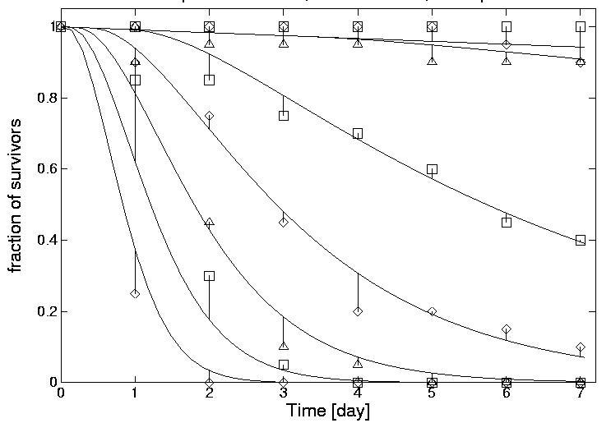
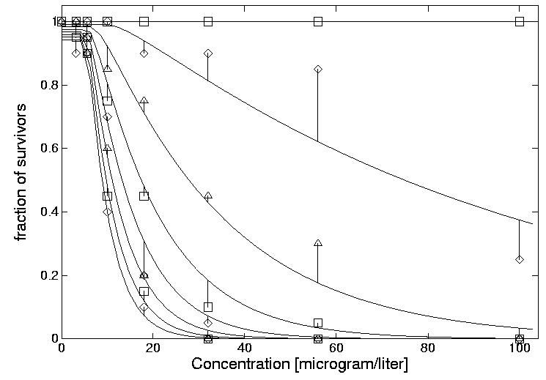
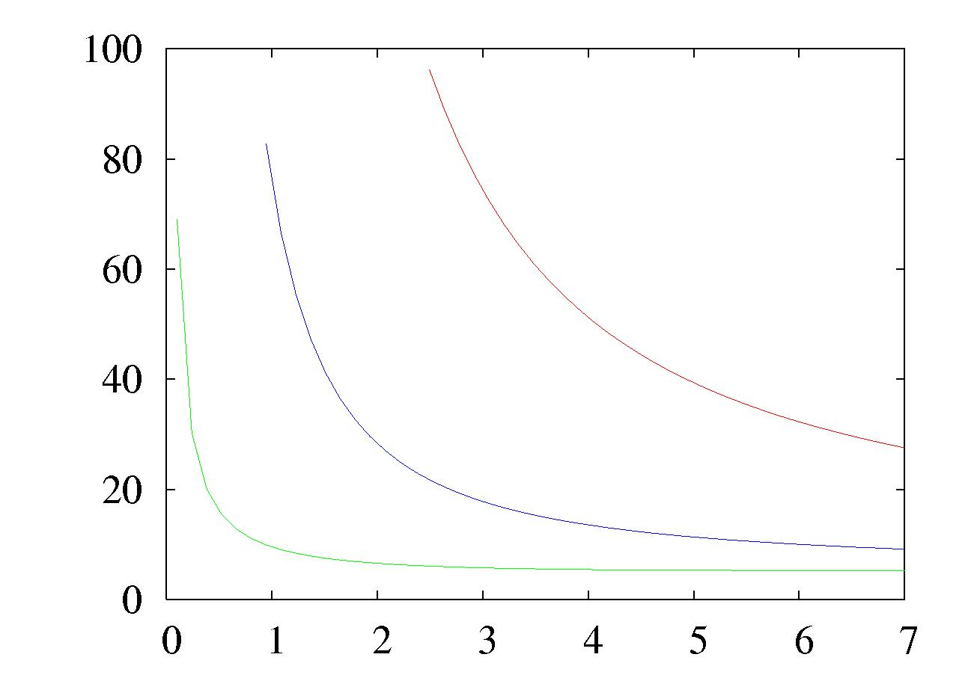
LCx, mg/l
time, d
Figure 7.2 The time and concentration profiles of the hazard model, together with the data of Figure 7.7. The resulting ML estimates are : control hazard rate = 0.0083 1/d, NEC = 5.2 µg/l, killing rate 0.037 (µg.d)⁻¹, elimination rate = 0.79 d⁻¹. From the last three parameters, LCx-time curves can be calculated, curves for the LC0, LC50 and LC99 are shown. (Calculated with DEBtox and DEBtool, see 7.9). For long exposure times, the LCx curves will tend towards the NEC, for all x, in absence of blank mortality.

As is shown, the three exposure- time-independent parameters of the hazard model completely determine the response surface, so the LCx-time curves. It is even possible to reverse the reasoning. If the LC50.1d = 50 mM, LC50.2d = 30 mM and LC50.3d = 25 mM, the NEC = 17.75 mM, the killing rate = 0.045 1/(mM.d), the elimination rate = 2.47 1/d. Such reconstructions are not very reliable, however, but they improve somewhat if more LC50 values are used.

If the observation times are very close together, the resulting huge matrix of survival-count data can be reduced to time-to-death data. Concentration-response modelling is traditionally considered to be different from time-to-death modelling, c.f. Newman et al (1989), Dixon & Newman (1991), Diamond et al (1991), but in the framework of biology-based models, these two approaches are just extreme cases of analyses of response-surfaces; their distinction vanishes and we generally deal with mixtures of both.The log likelihood function then reduces to
$l=\sum_{i}{\text{ln}h(t_{i})}−\sum_{j}{}\int{h(s)\text{ds}}$
where the first summation is across the individuals that actually died at the observed time points (excluding the ones that are taken alive out of the experiment, for instance at the end of the experiment, or because their internal concentration is measured in a destructive way) and the second one is across all individuals (the ones that died, as well as the ones that were removed alive). This sampling scheme allows that the concentrations for all individuals differ.

An example of application is as follows:
Time-to-death and concentration pairs (in d and mM, respectively):
(21,1); (20,1.1); (20,0.9);(18,1.2); (16,1.3); (16,1.4); (15,1.5); (10,2); (9,1.8); (6,2.2); (5,2.5); (2,3); (2,4.3); (1,5); (1,4.5). Time-of-removal and concentration pairs: (21,0); (21,0); (21,0); (21,1). The ML estimates for this combined data set for 19 individuals in total are: control hazard rate = 0.061 d${}^{−1}$, NEC = 1.93 mM, killing rate = 0.33 1/(mM.d), elimination rate 0.75 d${}^{−1}$. This means, for instance, that the LC50.2d = 5.6 mM and the LC50.21d = 2.06 mM. (Calculations with DEBtool, see 7.9.2)

The link between the DEB theory and the survival model is in the ageing module of the DEB model, where the hazard rate, as affected by the ageing process, depends on the respiration rate in a particular way due to the action of free radicals; genotoxic compounds have a very similar mode of action and these compounds accelerate the ageing process (Kooijman, 2000). The processes of tumour induction and growth have direct links with the ageing process (van Leeuwen and Zonneveld, 2001). These effects on survival are beyond the scope of the present document, which deals with survival during (short) standardised exposure experiments.
On the assumption that test animals do not recover from immobilisation, the concept “death” can be replaced by “initiation of immobilisation” in this model. Due to the non-linearity that is inherent to toxico-kinetics, this model does not belong to the class of generalised linear models for survival, which has been proposed for the analysis of toxicity data (Newman 1995, McCullagh & Nelder 1989).

The model for effects on survival, and details about the statistical properties of parameter estimates (especially that of NECs) are discussed in Andersen et al (2000), Bedaux & Kooijman (1994), Klepper & Bedaux (1997, 1997a), Kooijman & Bedaux (1996, 1996a). Effects at time-varying concentrations are discussed in Péry et al (2001, 2001a), Widianarko & van Straalen (1996).

Body growth
The DEB model allows for (at least) three routes for affecting body growth:
- a decrease of the assimilation rate. Assimilation deals with the transformation from food into reserves, and can be affected by a decrease of the feeding rate, or a decrease of the digestion efficiency.
- an increase of the somatic maintenance costs. These costs comprise protein turnover, the maintenance of intracellular and intra-organismal concentration gradients of compounds, osmo-regulation, heating of the body (mainly in birds and mammals), activity and other drains on resources that are not linked to processes of net synthesis. Somatic maintenance costs directly compete with body growth for resources (in the DEB model). So an increase of maintenance costs directly results in a decrease of body growth, due to conservation of mass and energy.
- an increase in the specific costs for growth. This is the case where the resource allocation to body growth is not affected, but the conversion of these resources to new tissue is.

This list does not exhaust all possibilities. An interesting alternative is in the change of the allocation to somatic maintenance plus body growth versus maturity maintenance and maturation (or reproduction). Under control conditions, the DEB model takes the relative investments in these two destinations to be constant (the absolute investments can change in time). Parasites and endocrine disrupting compounds (e.g. Andersen et al 2001, Kooijman, 2000) are found to change these relative investments. It is possible that a large number of compounds have similar effects. A practical problem in the application of a model that accounts for changes in the allocation fraction is that standardised bioassays for body growth do not include measurements that are necessary to quantify the effect appropriately. Detailed modelling of effects on mammalian development has been developed and applied (Setzer et al 2001, Lau et al 2000), but such approaches require adequate data and are specific for the compound as well as the test organism.

The following assumptions specify the effect on body growth at any concentration of test compound:
- Assumption on control behaviour
  - the test-organisms follow a von Bertalanffy growth curve in the control.
- Assumption on toxico-kinetics
  - the test chemical follows first order kinetics.
(Dilution by growth is taken into account.)
- Assumption on effects
One of three modes of action occur
  - the assimilation rate decreases linearly in the internal concentration.
  - the maintenance rate increases linearly in the internal concentration.
  - the costs for growth increases linearly in the internal concentration.
- Assumptions on measurements/toxicity test
  - the concentrations of test-compound are constant during exposure.
  - the measured body lengths are independently normally distributed with a constant variance

The von Bertalanffy growth curve is given by $L(t)=L_{∞}−(L_{∞}−L_{0})\text{exp}\left\{−r_{b}t\right\}$, where L(t) is the length at time t, $L_{0}$ is the initial length, $L_{∞}$ is the ultimate length, and $r_{b}$is the von Bertalanffy growth rate. The DEB model predicts that body growth is of the von Bertalanffy type only at constant food densities, in the case of isomorphs (i.e., organisms that hardly change in shape during growth). An implied assumption is, therefore, that food density is constant, or high. Food intake depends hyperbolically on food density in the DEB model; variations in food density, therefore, hardly result in variations in food intake as long as food remains abundant. Examples of application of the model of effects on growth by an increase of the maintenance costs and by a decrease of assimilation are as follows:
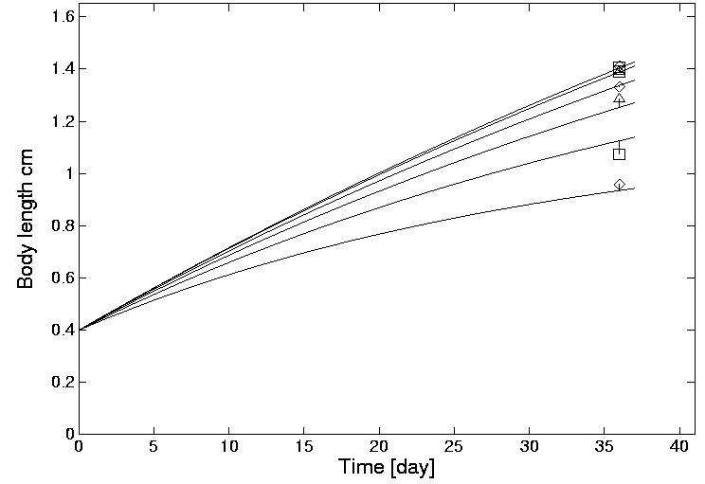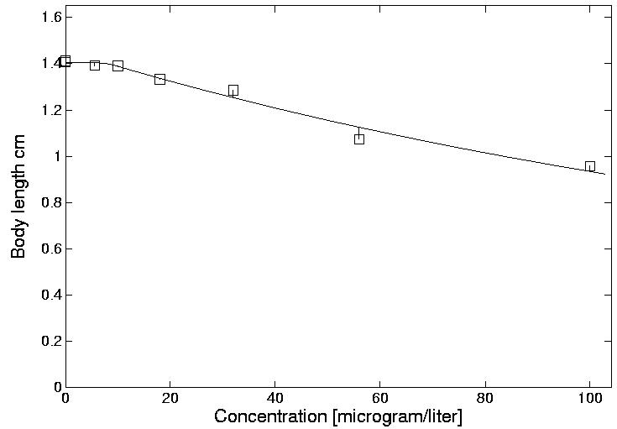
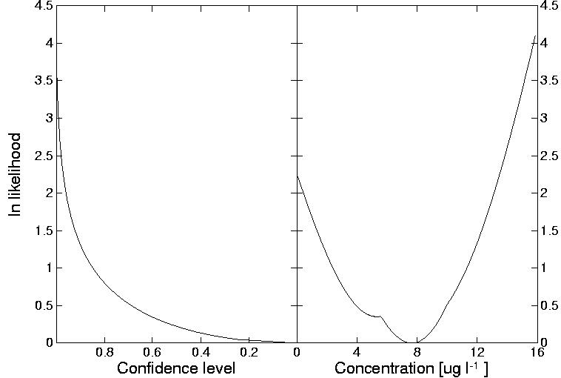
Figure 7.3 The time and concentration profiles for effects on growth of Pimephalus promelas via an increase of specific maintenance costs by sodium pentachlorophenate (data by Ria Hooftman, TNO-Delft). The parameters estimates are: NEC = 7.65 g/l; control ultimate length = 37 mm; tolerance conc = 43.5 g/l; elimination rate = large; Fixed parameters are: initial length = 4 mm; von Bertalanffy growth rate = 0.01 d. The profile likelihood function for the NEC is given left. The EC0.36d = 766g/l; EC50.36d = 176 g/l. The use of the profile likelihood graphs to obtain confidence intervals is explained in the legend to Figure 7.8.
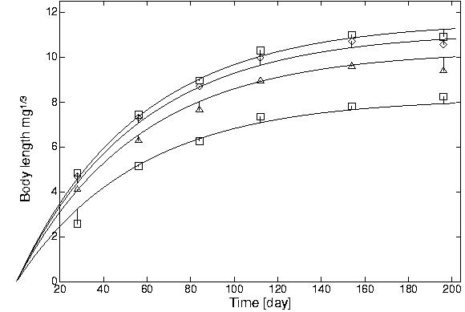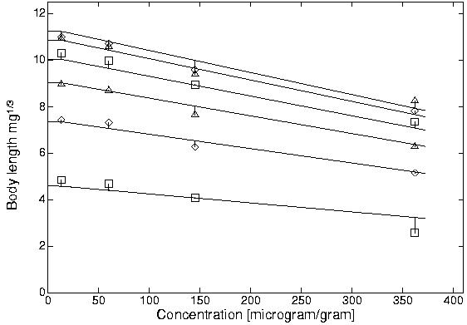
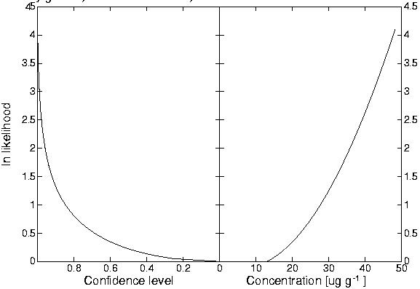
Figure 7.4 The time and concentration profiles for effects on growth of Lumbricus rubellus via a decrease of assimilation by copper chloride (data from Klok & de Roos 1996). The parameters estimates are: NEC = 13 g/g; control ultimate length = 11.6 mm; tolerance conc = 1.2 mg/g; elimination rate = large; Fixed parameters are: initial length = 0 mm; von Bertalanffy growth rate = 0.018 d. The profile likelihood function for the NEC is given left. The EC0.100d = 13g/g; EC50.100d = 605 g/g.
The first example shows that it is not necessary to have observations in time; the second example shows that it is not absolutely necessary to have a control. Although inclusion of a control is always radvisable, the control is treated in the same way as positive concentrations in the DEBtox method. The statistical properties of the parameter estimates and the confidence one has in them obviously improve if controls and positive concentrations are available.

At high concentrations, the test compound probably not only affects body growth, but usually also survival. The DEBtox software (see section 7.9) accounts for differences in number of individuals of which the body size have been measured.
The models for effects on body growth, and details about the statistical properties of parameter estimation (especially that of NECs) are discussed in Kooijman & Bedaux (1996, 1996a)

Reproduction
The DEB model allows for (at least) five routes that affect reproduction. The first three routes are identical to that for growth and are called the indirect routes. The DEB model assumes namely that food intake is proportional to surface area, so big individuals eat more than small ones. This makes, that if growth is affected, feeding is directly or indirectly affected as well, which leads to a change in resources that are available for reproduction. The routes not only lead to a reduction of reproduction, but also to a delay of reproduction. In addition there are two direct routes for affecting reproduction
- an increase in the costs per offspring, so an effect on the transformation from reserves of the mother to that of the embryo
- death of early embryos, before they leave the mother. Dead embryos can be born, or are absorbed; only the living ones are counted.
These two direct routes assume that the allocation to reproduction is not affected by the compound, but that the compound affects the conversion of these resources into living embryos.

The following assumptions specify the effect on reproduction at any concentration of test compound:
- Assumptions on control behaviour
  - the test-organisms follow a von Bertalanffy growth curve in the control
  - reproduction depends on assimilation, maintenance and growth as specified by the Dynamic Energy Budget (DEB) theory
- Assumption on toxico-kinetics
  - the test chemical follows first order kinetics (Dilution by growth is taken into account.)
- Assumptions on effects One of five modes of action occur
  - the assimilation rate decreases linearly in the internal concentration
  - the maintenance rate increases linearly in the internal concentration
  - the costs for growth increases linearly in the internal concentration
  - the costs for reproduction increases linearly in the internal conc.
  - the hazard rate of the neonates increases linearly in the internal conc.
- Assumptions on measurements/toxicity test
  - the concentrations of test-compound are constant during exposure.
  - the measured cumulative numbers of young per female are independently normally distributed with a constant variance

An implication of the DEB theory is that indirect effects on reproduction (the first three modes of action) are a reduction of the reproduction rate as well as a delay of the start of reproduction, while direct effects (the last two modes of action) involve a reduction of reproduction only. All three indirect effects on reproduction also have effects on growth, despite the fact that just a single target parameter is affected. The delay of the onset of reproduction is, therefore, coupled to effects on growth. The measurement of body lengths at the end of the bioassay on reproduction can be used as an easy check and as an identification aid to the mode of action. This mode of action is of importance to translate effects on individuals into those on growing populations (Kooijman 1985, Nisbet et al 2000).
The DEBtox software (see section 7.9) accounts for possible reductions of numbers of survivors in the reproduction test via weight coefficients; the more females contribute to the mean reproduction rate per female, the more weight that data point has in the parameter estimation. An example of application is from the OECD ring-test for effects of cadmium on Daphnia reproduction (Fig 7.5); the full results are reported in Kooijman at al (1998):
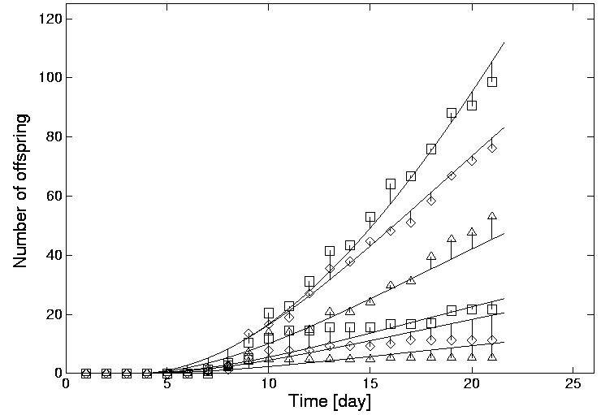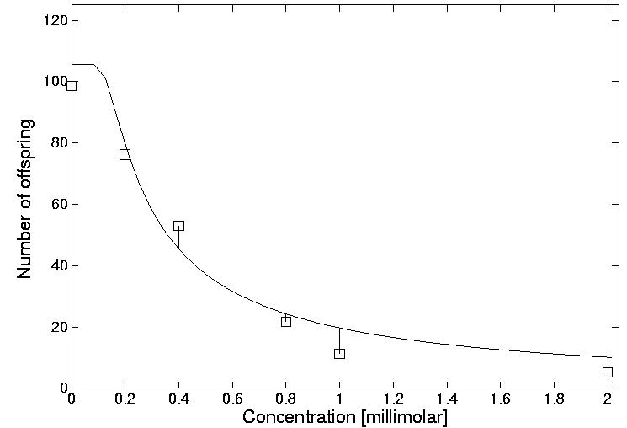
Figure 7.5 Effects of cadmium on the reproduction of Daphnia magna through an increase of the costs per offspring. Data from the OECD ring-test. The figures show the time and concentration profiles. The Parameter estimates are: NEC = 3.85 nM, tolerance conc = 5.40 nM, max reproduction rate = 14.4 d, elimination rate = 3.0 d. Fixed parameters are: von Bertalanffy growth rate = 0.1 1/d, scaled length at birth = 0.13, scaled length at puberty = 0.42, energy investment ratio = 1. The NEC does not differ significantly from 0 on the basis of these data. If a more accurate estimate is required, lower test concentrations should be selected. These parameter values imply: EC0.21d = 0.1 mM and EC50.21d = 0.336 mM.

The models for effects on reproduction, and details about the statistical properties of parameter estimation (especially that of NECs) are discussed in Kooijman & Bedaux (1996b, 1996c).

Population growth
If individuals follow a cycle of embryo, juvenile and adult stages, one needs the context of physiologically structured population dynamics to link the behaviour of population dynamics to that of individuals. If the individuals only grow and divide, a substantial simplification is possible in the context of the DEB model. This is the case in the algal growth inhibition bioassays, and in bioassays with duckweed, for instance.
Three modes of action of the compound are delineated here. The following assumptions specify the model for effects on populations:
- Assumptions on control behaviour
  - the viable part of the population grows exponentially (the cultures are not nutrient or light limited during the bioassay)
- Assumption on toxico-kinetics
  - the internal concentration is rapidly in equilibrium with the medium
- Assumptions on effects
One of three modes of action occur
  - the costs for growth are linear in the (internal) concentration
  - the hazard rate is linear in the (internal) concentration during a short period at the start of the experiment
  - the hazard rate is linear in the (internal) concentration during the experiment
- Assumptions on measurements/toxicity test
  - the concentrations of test-compound are constant during exposure.
  - the inoculum size is the same for all experimentally tested concentrations
  - biomass measurements include living and dead organisms
  - the measured population sizes are independently normally distributed with a constant variance
The rationale of the second mode of action (death only at the start of the experiment) is that effects relate to
- the transition from control culture to stressed conditions, not to the stress itself
- the position of the transition in the cell cycle; Cells are not synchronised, so the transition occurs at different moments in the cell cycle, for the different cells. If cells are more sensitive for the transition during a particular phase in the cell cycle, only those cells are affected that happen to be in that phase.
The ECx values for this type of bioassay can be calculated in various ways, with different results. One way to do this is on the basis of biomass as a function of time. This should not be encouraged, however because the result depends on experimental design parameters that have nothing to do with toxicity (Nyholm 1985). Another way to do this is on the basis of specific population growth rates, which are independent of time (Kooijman et al 1996a). An example of application of the DEBtox method is as follows
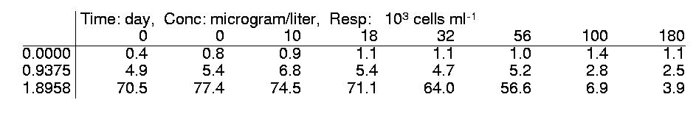
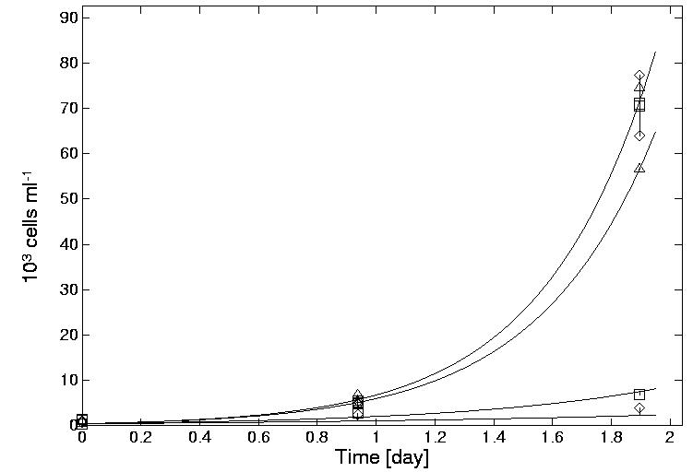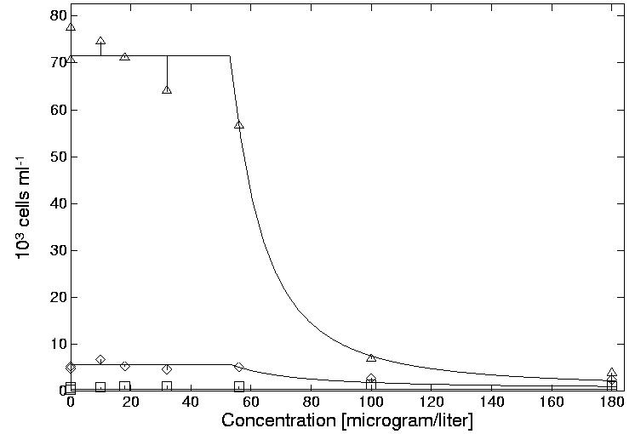
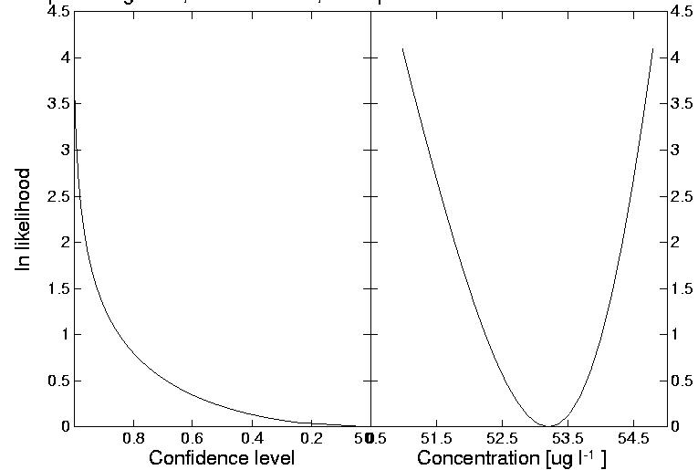
Figure 7.6. The effect of a mixture of C,N,S-compounds on the growth of Skeletonema costatum via an increase of the costs for growth (data from the OECD ring test). The figures show the data, and the time and concentration profiles (note that this data set contains two blanks). The estimated parameters are: inoculum = 494 cells/ml, specific growth rate = 2.62 1/d, NEC = 0.053 mg/l, tolerance conc = 0.0567 mg/l. The profile likelihood function for the NEC is given in the figure left. The EC50 = 0.0624 mg/l. The robustness of this approach is demonstrated by the fact that removal of the highest concentration leads to the same point estimate for the NEC (but with a larger confidence interval).

The model for effects on population growth, and details about the statistical properties of parameter estimation (especially that of NECs) are discussed in Kooijman et al (1996a). Toxic effects on logistically growing populations in batch cultures are discussed in Kooijman et al (1983); a paper on the interference of toxic effects and nutrient limitation is in preparation.

Parameters of effect models
The parameters of effect models can be grouped into a set that relates directly to the effects of the test compound and a set that relates to the eco-physiological behaviour of the test organisms.

Effect parameters
The basic biology-based models have two toxicity parameters and a single dynamic parameter:
- NEC = EC0(∞): No-Effect Concentration, which is the 0% effect level at very long exposure times (dimension: external concentration).
- killing rate (for effects on survival; dimension: per external concentration per time) or tolerance concentration (for sublethal effects; dimension: external concentration).
- elimination rate of first order kinetics (for survival, body growth and reproduction tests; not for population growth inhibition tests. Dimension: per time). Large values mean that the internal concentration rapidly reaches equilibrium with the concentration in the medium. If the internal concentration is in equilibrium, the effects no longer change. Notice that the elimination rate has no information about the toxicity of the test compound.
The killing rate is the increase in the hazard rate per unit of concentration of test compound that exceeds the NEC:
- $$\text{hazard rate }=\text{ control hazard rate }+\text{ killing rate }{\left(\frac{\text{internal concentration}}{\text{BCF}}−\text{NEC}\right)}_{+}$$
where BCF = Bio-Concentration Factor and where the symbol ${}_{+}$ means that if internal conc./BCF is below NEC, them hazard rate equals control hazard rate. The BCF stands for the ratio of the internal and external concentration in equilibrium. No assumptions are made about its value; it can be very small for compounds that hardly penetrate the body.

The tolerance concentration quantifies the change in the target parameter per unit of concentration of test compound that exceeds the NEC:
- parameter value = control parameter value (1 + stress value)
- $\text{stress value }= \frac{1}{\text{tolerance concentration}}{\left(\frac{\text{internal concentration}}{\text{BCF}}−\text{NEC}\right)}_{+}$
where BCF = Bio-Concentration Factor.

The target parameter value in this specification of the tolerance concentration can be the specific costs for growth, the specific maintenance costs or another physiological target parameter. This depends on the mode of action of the compound.
The name “tolerance concentration” refers to the fact that the higher its value, the less toxic the chemical compound. Notice that the ratio “internal concentration/ BCF” has the interpretation of an external concentration that is proportional to the internal concentration; the tolerance concentration, like the NEC, has the dimension of an external concentration. This is done because internal concentrations are generally unknown in practice. The internal concentration, and so the stress value, depends on the (constant) external concentration and the (changing) exposure time. The stress value is a dimensionless quantity, which is only introduced to simplify the specification of the change in the target parameter.

The NEC, the elimination rate and the tolerance concentration (or killing rate) are parameters that do NOT depend on the exposure time. This is in contrast to ECx values, which do depend on exposure time. Notice that the accumulation rate (a toxico-kinetic parameter) does not occur in the parameter set of effect models. This is because less toxic compounds that accumulate strongly cannot be distinguished from toxic compounds that hardly accumulate if only effects, and no internal concentrations, are observed. This is also the reason why NECs, killing rates and tolerance concentrations are in terms of external concentrations, while the mechanism is via internal concentrations. Effect models treat internal concentrations as hidden variables.

The kinetic parameters depend on the properties of the chemical compound. The elimination rate is inversely proportional to the square-root of the octanol-water partition coefficient (P_{ow}), while the uptake rate is proportional to the square-root of this coefficient (Kooijman & Bedaux 1996, Kooijman 2000). Since effects depend on internal concentrations, so on toxico-kinetics, effect parameters depend on the partition coefficient as well; the NEC, tolerance concentration and inverse killing rate are all inversely proportional to the P_{ow} (Gerristen 1997, Kooijman & Bedaux 1996, Kooijman 2000). Such relationships can be used in practice to test parameter estimates against expectations.

The prediction of how the toxicity parameters depend on the octanol-water partition coefficient can be used for selecting appropriate concentrations to be tested. An example is as follows.
Suppose that compound 1 with P_{ow} = 10⁶ has been tested of its effects on survival, which resulted in the parameter estimates: NEC = 1.3 mM; killing rate = 1.5 1/(mM.d); elimination rate = 0.5 1/d. Now have to test compound 2, with a physiologically similar mode of action and a P_{ow} = 10⁷. expect to find the parameter estimates NEC = 0.13 mM; killing rate = 15 1/(mM.d); elimination rate = 0.5/√10= 0.16 1/d. These three parameters imply that the LC0.2d = 0.47 mM and the LC99.2d = 1.9 mM, which gives some guidance for choosing the concentration range to be tested in a test of 2 d.
Suppose now that we tested compound 1 for effects on reproduction in Daphnia with a control max reproduction rate of 15 offspring per day. Let assume that the compound increases the maintenance costs. This resulted in NEC = 1.3 mM, tolerance concentration = 10 mM; elimination rate = 0.5 1/d. We expect to find for compound 2: NEC = 0.13 mM, tolerance concentration = 1 mM; elimination rate = 0.16 1/d. These three parameters imply that the EC0.21d = 0.18 mM and the EC99.21d = 1.9 mM, which gives some guidance for choosing the concentration range to be tested in a reproduction test of 21 d. (Calculations with DEBtool, see 7.9.2)

Contrary to more usual techniques to establish Quantitative Structure Activity Relationships (QSARs), the influence of the P_{ow} on the parameters of biology-based models can be predicted on the basis of first principles; these QSARs are not derived from regression techniques that require toxicity data for other compounds. The reason why traditional regression techniques for establishing QSARs are somewhat cumbersome is in the standardisation of the exposure period. For any fixed exposure period (usually 2d or 14d) the LC50 (or EC50) for a compound with a low P_{ow} is close to its LC50 for very long exposure times; for compounds with a large P_{ow}, however, the ultimate LC50 is much lower than the observed one. If we compare LC50s for low and high P_{ow} values, we observe complex deviations from simple relationships, which are masked in log-log plots and buried in the allometric models that are usually applied to such data. (An allometric model is a model of the type y(x) = a x^{b} where a and b are parameters.)

Effects of modifying factors, such as pH, can be predicted, and taken into account in the analysis of toxicity data (corrections on measured or nominal concentrations, and on measured or modelled pH values). If the compound affects the pH at concentrations where small effects occur, and the NEC and/or the killing rate of the molecular and ionic forms differ, the relationships
$b_{k}(\text{pH})=\frac{b_{k}^{m}+b_{k}^{i}{\text{10}}^{\text{pH}−\text{pK}}}{1+{\text{10}}^{\text{pH}−\text{pK}}}$ and $c_{0}(\text{pH})=c_{0}^{i}c_{0}^{m}\frac{1+{\text{10}}^{\text{pH}−\text{pK}}}{c_{0}^{i}+c_{0}^{m}{\text{10}}^{\text{pH}−\text{pK}}}$
apply, where pK is the ion-product constant, and are the NECs of the molecular and ionic forms, and are the killing rates of the molecular and ionic forms (Kooijman 2000, Könemann 1980). The pH is affected much more easily in soft than in hard water (see e.g. Segel 1976, Stumm & Morgan 1996). Compounds may effect internal pH to some extent; in that case the relationship is approximately only.

On the assumption that the chemical environment inside the body of the test organisms is not affected (due to homeostatic control), the observed survival pattern can be used to infer about the toxicity of the molecular and the ionic form. The partitioning between the molecular and ionic form is fast relative to the uptake and elimination (both in the environment and in the organism); this makes that the elimination rate relates to both the molecular and the ionic form. An example is as follows.

PH | 7.5 | 7.5 | 7.4 | 7.2 | 6.9 | 6.6 | 6.3 | 6.0
Conc | 0 | 3.2 | 5.6 | 10 | 18 | 32 | 56 | 100
0 | 20 | 20 | 20 | 20 | 20 | 20 | 20 | 20
1 | 20 | 20 | 20 | 20 | 20 | 20 | 19 | 18
2 | 20 | 20 | 19 | 19 | 19 | 18 | 18 | 18
3 | 20 | 20 | 17 | 15 | 14 | 12 | 9 | 8
4 | 20 | 18 | 15 | 9 | 4 | 4 | 3 | 2
5 | 20 | 18 | 9 | 2 | 1 | 0 | 0 | 0
6 | 20 | 17 | 6 | 1 | 0 | 0 | 0 | 0
7 | 20 | 5 | 0 | 0 | 0 | 0 | 0 | 0

Suppose that we found the numbers of survivors as in the left table for a compound with ionisation product constant of 9.0. The parameter estimates are (calculations with DEBtool, see 7.9.2):

 | Molecule |  | Ion
 | ML | sd | ML | Sd
Control mort rate | 0.009 | 0.005
NEC | 24.9 | 16.9 | 0.17 | 0.03
Killing rate | 0.039 | 0.013 | 2.82 | 2.16
Elimination rate | 1.48 | 0.50

The elimination rate is proportional to the ratio of a surface area and a volume of the test organism, which yields an inverse length measure. This relationship implies predictable differences between elimination rates in organisms of different sizes, which have been tested against experimental data (see e.g. Gerritsen 1997). This is rather straightforward in the case of individuals of the same species, but also applies to individuals of different, but physiologically related, species. The body size scaling relationships as implied by the DEB theory suggest predictable differences in the chemical body composition, so in lipid content and in elimination rate and toxicity parameters. Such relationships still wait for testing against experimental data, but are helpful in developing an expectation for parameter values; such expectations can be used in experimental design, and in checking results of parameter estimations.

The prediction of how the three parameters of the hazard model depend on the body size of the test organisms can also be used for selecting appropriate concentrations to be tested. An example is as follows:
Suppose that a compound has been tested using fish of a weight of 1 mg, which resulted in the parameter estimates: NEC = 1.3 mM; killing rate = 1.5 1/(mM.d); elimination rate = 0.5 1/d. Now we have to test the compound for fish of 1 g of the same species. We expect to find a difference in the elimination rate only, i.e. 0.5/10= 0.05 1/d. These three parameters imply that the LC0.2d = 1.4 mM and the LC99.2d = 5.5 mM, which gives some guidance for choosing the concentration range to be tested in a test of 2 d. (Calculations with DEBtool, see 7.9.2)

Eco-physiological parameters
The model for effects on survival has the control mortality rate as parameter, which results in an exponentially decaying survival probability. This means that the model delineates two causes for death: death due to background causes (for instance manipulation during the assay) and death due to the compound. This obviously complicates the analysis of the death rate at low exposure levels, because we can never be sure about the actual cause of death in any particular case. Not only the data in the control, but all data are used to estimate the control mortality rate; if no death occurs in the control, this does not imply that the control mortality rate is zero. The profile likelihood function for the NEC quantifies the likelihoods of the two different causes of death. Figures 7.2, 7.3 and 7.4 show how background causes can be distinguished from those by the compound.
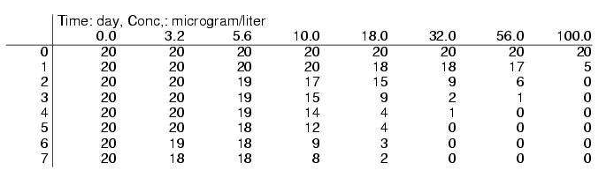
Figure 7.7 A typical table of data that serves as input for the survival model, as can be used in the software package DEBtox (Kooijman & Bedaux 1996). The data in the body represent the number of surviving guppies. The first column specifies the observation times in days, the first row specifies the concentrations of dieldrin in g/l. Figure 7.8 shows how an answer can be found to the question whether the two deaths in the concentrations 3.2 and 5.6g/l are due to dieldrin, or to “natural” causes.

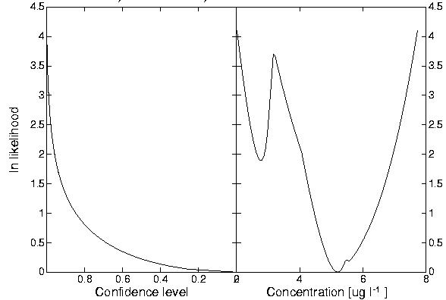
Figure 7.8 This profile likelihood function of the NEC (right panel) for the data in Figure 7.7 results from the software package DEBtox (Kooijman & Bedaux 1996). It determines the confidence set for the NEC (first select the confidence level of your choice in the left panel, then read the ln likelihood; the concentrations in the right panel for which the ln likelihoods are below this level comprise the confidence set of the NEC; the confidence set for the NEC is a single interval for low confidence levels, but a set of two intervals for high confidence levels). The maximum likelihood estimate for the NEC is here 5.2 g/l, and corresponds to the interpretation of death in concentration 3.2g/l due to “natural” causes; the second local extreme at 2.9g/l corresponds to the interpretation of this death due to dieldrin. The figure shows that this interpretation is less likely, but the figure shows that we cannot be excluded this possibility for high confidence levels. If the lowest concentration would have no deaths in this data set, the profile likelihood function would not have a second local extreme.

The model for effects on growth have a single eco-physiological parameter each (the ultimate body length, and the maximum reproduction rate), that is estimated from the data, and a scatter parameter that stands for the standard deviation of the normally distributed deviations from the model predictions. The latter parameter also occurs in the models for effects on population growth.

The models for effects on body growth and reproduction have some parameter values that cannot be estimated from (routine) bioassays. Their values should be determined by preliminary eco-physiological experiments. These parameters are
- von Bertalanffy growth rate (dimension: per time). This parameter quantifies how fast the initial length approaches the ultimate length at constant food density. (The food density affects this parameter.) In principle, its value could be extracted from length measurements in the control, provided that enough observation times are included. Under standardised experimental conditions, its value should always be the same, however. Moreover, the lengths are usually only measured at the end of the bioassay only. These data do not have information about the value of the von Bertalanffy growth rate.
- initial body length (dimension: length), which is the body length at the start of the bioassay. It is assumed that this applies to all individuals in all concentrations. The DEB model for reproduction has a scaled length at birth as parameter, which is dimensionless. This scaled length is the ratio of the length at birth and the maximum length of an adult at abundant food. Since the daphnia reproduction bioassay uses neonates, the initial body length equals the length at birth.
- scaled length at puberty (dimensionless). This is the body length at the start of reproduction in the control as a fraction of the maximum body length of an adult at abundant food. The DEB model takes this value to be a constant, independent of the food density. At low food density, it takes a relatively long time to reach this length. The start of reproduction, therefore, depends on food density. The model for effects on reproduction needs the length at puberty. That on body growth does not use this parameter.
- energy investment ratio (dimensionless). This parameter stands for the ratio between the specific energy costs for growth and the product of the maximum energy capacity of the reserves and the fraction of the catabolic energy flux that is allocated to somatic maintenance plus growth. The maximum (energy) capacity of the reserves is reached after prolonged exposure to abundant food. The catabolic flux is the flux that is mobilised from the reserves to fuel metabolism (i.e. allocation to somatic and maturity maintenance, growth, maturation or reproduction; the relative allocation to somatic maintenance plus growth is taken to be constant in the DEB model). The value of the parameter does not affect the results in a sensitive way. The logic behind the DEB theory requires its presence, however; the parameter plays a more prominent role at varying food densities.
The DEBtox software (see below) fixes these parameters at appropriate default values for the standardised bioassays on fish growth and daphnia reproduction. The user can change these values.

The models for population growth have two eco-physiological parameters that are estimated from the data
- the inoculum size (dimension: mass or number per volume), which is taken to be equal in all concentrations
- the control specific population growth rate (dimension: per time)

Recommendations

Goodness of fit
As applies to all models that are fitted to data, one should always check for goodness of fit (as incorporated in DEBtox), inspect the confidence intervals of the NEC, and mistrust any conclusion from models that do not fit the data (see also Section 6.4). The routine presentation of graphs of model fits is strongly recommended. “True” models, however, not always fit the data well, due to random errors. If deviations between data and model-fits are unacceptably large, it makes sense to make sure that the experimental results are reproducible. Problems with solubility of the test compound, pH effects, varying concentrations, varying conditions of test animals, interactions between test animals and other factors can easily invalidate model assumptions. It might be helpful to realise that one approach for solving this problem is in taking such factors into account in the model (and apply a more complex model), but another approach is to change the experimental protocol such that the problems are circumvented. The models are designed to describe small effects; if the lack of fit relates to large effects, it can be recommended to exclude the high concentration(s) from the data analysis.

Any model might fit data well for the wrong reasons; a good fit does not imply the “validity” of that model. This should motivate to explore all possible means for checking results from data analysis; an expectation for the value of parameters is a valuable tool.

The assumption of first order kinetics is not always realistic in detail. A general recommendation is to consider more elaborate alternatives only if data on toxico-kinetics are available. Depending on the given observation times, the elimination rate is not always accurately determined by the data. In such cases one might consider to fix this parameter at a value that is extracted from the literature, and/or derived from a related compound, after correction for differences in P_{ow} values.

Choice of modes of action
Experience teaches that the mode of action usually has little effect on the NEC estimates. Models for several modes of action frequently fit well to the same experimental data set; if additional type of measurements would have been available (such as feeding rate and/or respiration rate), it is much easier to choose between modes of action. These modes of action are of importance to translate effects on individuals to those on population dynamics, and how food availability interferes with toxic effects. The DEB theory deals with this translation.
Measurements of feeding and respiration rates, and of body size (in reproduction tests) greatly help identifying the mode of action of the compound. The proper identification of the mode of action is less relevant for estimates of the NEC.

Experimental design
DEBtox has been designed to analyse the results from bioassays as formulated in OECD guidelines (numbers 201, 202, 203, 204, 211, 215, 218, 219) and ISO guidelines (numbers 6341, 7346-3, 8692, 10229, 10253, 12890, 14669). The experimental design described in these guidelines is suitable for the application of DEBtox. Confidence intervals for parameter estimates are greatly reduced if not only the responses at the end of the toxicity experiments are used, but also observations during the experiment. Ideally, one should be able to observe how fast effects build up during exposure in the data, till the effect levels satiate. Note that this does not require additional animals to be tested, only that they are followed for a longer period of time.

Large extrapolations of effects, especially in the direction of longer exposure times, are generally not recommended; this is because, ideally, the assumptions need to be checked for all new applications. It, therefore, makes sense to let the optimal choice for the exposure period depend on the compound that is tested, and the test organisms that is used. The higher the solubility in fat of the test compound (e.g. estimated from P_{ow}), and the larger the body size of the test organisms, the longer the exposure should last.

As has already been stated in the introduction, it is strongly recommended to include all available observations into the analysis; not only those at the end of the experiment, but also the observations that have been collected during the experiment (for instance when the media are refreshed). It is generally recommended that the number of observations during exposure, the concentrations of test compound and the number of used test animals are such that the model parameters can be estimated within the desired accuracy.

Experimental design should optimise the significance of the bioassay; the significance of single-species tests is discussed in Anonymous (1999). From a data analysis point of view it makes sense to extend the exposure period till no further effects show up. The length of the exposure period then relates to the physical-chemical properties of the compound.

Building a database for raw data
Since biology-based methods not only aim at a description, but also at an understanding of the processes that underlie effects, it is only realistic to assume that this understanding will evolve over the years. It might be useful in the future, to reanalyse old data in the light of new insights. Anticipating on this situation, building a database for the raw data is recommended.

Software support
The models that are used by biology-based methods are fully derived and discussed in all mathematical detail in the open literature; a summary of the specification is given in the appendix of this report. There is, therefore, no need to use any of the software that is mentioned in this section. On the other hand, fitting sets of differential equations to data (as required by the models for effects on body growth and reproduction), the calculation of profile likelihoods for NECs, and the more advanced methods of fitting several datasets simultaneously, is beyond the capacity of most standard packages. Even if packages can do the job, the optimisation of numerical procedures (such as solving initial value problems) can be somewhat laborious.

The computations for biology-based methods have been coded in two packages, DEBtox and DEBtool, which can be downloaded freely from the electronic DEB-laboratory at http://www.bio.vu.nl/thb/deb/. Both packages are updated at varying intervals; the user has to check the website for the latest version. These packages are used in (free) international internet-courses that are organised by the Dept Theoretical Biology at the Vrije Universiteit, Amsterdam.

A Ms Excel macro able to estimate Hill parameters using nonlinear regression is available under the GPL license on the site: http://perso.wanadoo.fr/eric.vindimian

DEBtox
DEBtox is a load-module for Windows and Unix that is meant for routine applications.
The user cannot define new models. The package has many options for parameter estimation, confidence intervals and profile likelihoods (for the NEC for instance), fixation of parameters at particular values (such as NEC = 0) while estimating the other parameters, calculation of statistics (such as ECx.t and ETx.c values and their confidence intervals), hypothesis testing about parameter values (such as NEC ≠ 0), graphical representations to check goodness of fit, residual analysis, etc. Example data-files are provided for each bioassay.

DEBtox is a user-friendly package, and the numerical procedures are optimised for the various models (modes of action) that can be chosen. The elimination rate, for instance, is not always accurately determined by the data, especially if a single observation time is given. DEBtox always calculates three sets of parameter estimates, corresponding with the elimination rate being a free parameter, or zero, or infinitely large. Only the best result is shown. The initial values for the parameters that are to be estimated are selected automatically. In fact many trials (some hundred) are performed, and only the best result is shown. The user does not have to bother about these computational “details”. (The likelihood function can have many local maxima, depending on the model and on the observations. The result of the numerical procedure to find a local maximum depends on the initial value; are only interested in the global maximum, however. This problem complicates non-linear parameter estimation in practice; it is an extra reason to check the result graphically in all applications.)

The present version of DEBtox can handle a single endpoint only (i.e. a single table of observations of responses at the various combinations of concentration and exposure time). In the period 2002-2006 DEBtox will be extended to include multiple samples to allow the analysis of effects on survival and reproduction simultaneously, and to test hypotheses about differences of parameter values between samples.

DEBtool
DEBtool is source code (in Octave and Matlab®) for Windows and Unix that is meant for research applications. Octave is freely downloadable, Matlab is commercial. DEBtool is much more flexible than DEBtox, but requires more knowledge for proper use; it is less user-friendly than DEBtox. Initial values for parameter estimations are not automatic, for instance. DEBtool has many domains that deal with the various applications of DEB models in eco-physiology and biotechnology; the domain “tox” deals with applications in ecotoxicology. The package can handle multiple data sets; several numerical procedures can be selected to find parameter estimates. DEBtool allows to estimate parameters if the variance is proportional to the squared mean, to calculate the NEC, killing rate and elimination rate from LC50 values for three exposure times, to estimate parameters from time-to-death data, to extract the toxicity parameters for the molecular and the ionic form when the pH is measured for each concentration, etc. Many specific models are coded, and the user can change and add models.

References for chapter 7
Andersen H.R., Wollenberger L, Halling-Sorensen B. and Kusk K.O. (2001) - . Development of copepod nauplii to copepodites - A parameter for chronic toxicity including endocrine disruption. Environ. Toxicol. Chem. 20: 2821 – 2829
Andersen J.S., Bedaux J.J.M., Kooijman S.A.L.M. and Holst H. (2000) - The influence of design parameters on statistical inference in non-linear estimation; a simulation study. Journal of Agricultural, Biological and Environmental Statistics 5: 28 - 48
Anonymous (1999) - Guidance document on application and interpretation of single-species tests in environmental toxicology. Report EPS 1/RM/34, Minister of Public Works and Government Services, ISBN 0-660-16907-X
Bedaux J.J.M. and Kooijman S.A.L.M. (1994) - Statistical analysis of bioassays, based on hazard modelling. Environ. & Ecol. Stat. 1: 303 - 314
Chen C.W. and Selleck R.E. (1969) - A kinetic model of fish toxicity threshold. Res. J. Water Pollut. Control Feder. 41: 294 – 308.
Cox, D. R. and Oakes, D. (1984) - Analysis of survival data. Chapman & Hall, London.
Diamond, S.A., Newman, M. C., Mulvey, M. and Guttman, S.I. (1991)- Allozyme genotype and time to death of mosquitofish, Gambusia holbrooki, during acute inorganic mercury exposure: a comparison of populations. Aqua. Toxicol. 21: 119-134.
Dixon, P. M. and Newman, M. C. (1991) – Analyzing toxicity data using statistical models for time-to-death. In: Newman, M. C. and McIntosh, A. W. (eds) An introduction, in metal ecotoxicology, concepts and applications. Lewis Publishers, Chelsea, MI.
Elsasser W.M. (1998) - Reflections on a theory of organisms; Holism in biology. John Hopkins University Press, Baltimore.
Gerritsen A. (1997) - The influence of body size, life stage, and sex on the toxicity of alkylphenols to Daphnia magna. PhD-thesis, University of Utrecht
Garric J, Migeon B. and Vindimian E. (1990) - Lethal effects of draining on brown trout. A predictive model based on field and laboratory studies. Water Res. 24: 59-65
Hallam T.G., Lassiter R.R. and Kooijman S.A.L.M. (1989) - Effects of toxicants on aquatic populations. In: Levin, S. A., Hallam, T. G. and Gross, L. F. (Eds), Mathematical Ecology. Springer, London: 352 – 382
Harding G.C.H. and Vass W.P. (1979) - Uptake from seawater and clearance of p,p’-DDT by marine planktonic crustacea. J. Fish. Res. Board Can. 36: 247 – 254.
Heugens, E. H. W., Hendriks, A. J., Dekker, T., Straalen, N. M. van and Admiraal, W. (2001) - A review of the effects of multiple stressors on aquatic organisms and analysis of uncertainty factors of use in risk assessment. Crit. Rev Toxicol. 31: 247-284
Heugens, E. H. W., Jager, T., Creyghton, R., Kraak, M. H. S., Hendriks, A. J., Straalen, N. M. van and Admiraal. W. (2003) - Temperature-dependent effects of cadmium on Daphnia magna: accumulation versus sensitivity. Environ. Sci. Tehnol 37: 2145-2151.
Hill H.V. (1910) - The possible effects of aggregation on the molecules of haemoglobin on its dissociation curves. J. Physiol. (London) 40: IV-VII
Hoeven N. van der, Kooijman S.A.L.M. and Raat W.K. de (1990) - Salmonella test: relation between mutagenicity and number of revertant colonies. Mutation Res. 234: 289 – 302.
Jager, T. (2003) - Worming your way into bioavailability; modelling the uptake of organic chemicals in earthworms. PhD thesis, Utrecht University.
Jager, T., Baerselman, R., Dijkman, E., Groot, A. de, Hogendoorn, E., Jong, A. de, Kruitbosch, J. and Peijnenburg, W. (2003) - Availability of polycyclic aromatic hydrocarbons to earthworms (Eisenia Andrei, Oligochaeta) in field-polluted soils and soil-sediment mixtures. Environ. Tox Chem. 22: 767-775.
Janssen, M. P. M., Bruins, A., Vries, T. H. de and Straalen, N. M. van (1991) Comparison of Cadmium kinetics in 4 soil athropod species. Arch. Environ. Cont. Toxicol 20: 305-313
Kimerle R.A., Macek K.J., Sleight B.H. III and Burrows M.E. (1981) - . Bioconcentration of linear alkylbenzene sulfonate (LAS) in bluegill (Lepoma macrochirus). Water Res. 15: 251 – 256.
Klepper O. and Bedaux J.J.M. (1997) - Nonlinear parameter estimation for toxicological threshold models. Ecol. Mod. 102: 315 - 324
Klepper O. and Bedaux J.J.M. (1997a) - A robust method for nonlinear parameter estimation illustrated on a toxicological model Nonlin. Analysis 30: 1677 – 1686
Klok C. and de Roos A. M. (1996) - Population level consequences of toxicological influences on individual growth and reproduction of Lumbricus rubellus (Lumbricidae, Oligochaeta). Ecotoxicol. Environm. Saf. 33: 118-127
Könemann W.H. (1980) - Quantitative structure-activity relationships for kinetics and toxicity of aquatic pollutants and their mixtures for fish. PhD thesis, Utrecht University, the Netherlands.
Kooijman S.A.L.M. (1981) - Parametric analyses of mortality rates in bioassays. Water Res. 15: 107 - 119
Kooijman S.A.L.M. (1983) - Statistical aspects of the determination of mortality rates in bioassays. Water Res.: 17: 749 - 759
Kooijman S.A.L.M. (1985) - Toxicity at population level. In: Cairns, J. (ed) Multispecies toxicity, Pergamon Press, N.Y.: 143 - 164
Kooijman S.A.L.M. (1988) - Strategies in ecotoxicological research. Environ. Aspects Appl. Biol. 17 (1): 11 - 17
Kooijman S.A.L.M. (1997) - Process-oriented descriptions of toxic effects. In: Schüürmann, G. and Markert, B. (Eds) Ecotoxicology. Spektrum Akademischer Verlag, 483 - 519
Kooijman S.A.L.M. (2000) - Dynamic Energy and Mass Budgets in Biological Systems. Cambridge University Press
Kooijman S.A.L.M. (2001) - Quantitative aspects of metabolic organisation; a discussion of concepts. Phil. Trans. R. Soc. B, 356: 331 – 349
Kooijman S.A.L.M. and Bedaux J.J.M. (1996) - Some statistical properties of estimates of no-effects levels. Water Res. 30: 1724 - 1728
Kooijman S.A.L.M. and Bedaux J.J.M. (1996) - Analysis of toxicity tests on fish growth. Water Res. 30: 1633 - 1644
Kooijman S.A.L.M. and Bedaux J.J.M. (1996a) - Some statistical properties of estimates of no-effects concentrations. Water Res. 30: 1724 - 1728
Kooijman S.A.L.M. and Bedaux J.J.M. (1996b) - Analysis of toxicity tests in Daphnia survival and reproduction. Water Res. 30: 1711 - 1723
Kooijman S.A.L.M. and Bedaux J.J.M. (1996c) - The analysis of aquatic toxicity data. VU University Press, Amsterdam
Kooijman S.A.L.M., Bedaux J.J.M. and Slob W. (1996) - No-Effect Concentration as a basis for ecological risk assessment. Risk Analysis 16: 445 - 447
Kooijman S.A.L.M., Bedaux J.J.M., Gerritsen A.A.M., Oldersma H. and Hanstveit A.O. (1998) - Dynamic measures for ecotoxicity. Report of the OECD Workshop on Statistical Analysis of Aquatic Toxicity Data OECD Environmental Health and Safety Publications 10: 64-90. Also in: Newman, M.C. and Strojan, C., Risk Assessment: Logic and Measurement. Ann Arbor Press, 187 - 224
Kooijman S.A.L.M., Hanstveit A.O. and Nyholm N. (1996a) - No-effect concentrations in algal growth inhibition tests. Water Res. 30: 1625 - 1632
Kooijman S.A.L.M., Hanstveit A.O. and Oldersma H. (1983) - Parametric analyses of population growth in bioassays. Water Res. 17: 727 - 738
Kooijman S.A.L.M. and Haren R.J.F. van (1990) - Animal energy budgets affect the kinetics of xenobiotics. Chemosphere 21: 681 - 693
Lau C., Andersen M.E., Crawford-Brown D.J., Kavlock R.J., Kimmel C.A., Knudsen T.B., Muneoka K., Rogers J. M., Setzer R. W., Smith G. and Tyl R. (2000) -. Evaluation of biologically based dose-response modelling for developmental toxicology: A workshop report. Regul. Toxicol. Pharmacol. 31: 190 - 199
Leeuwen I.M.M. and Zonneveld C. (2001) - From exposure to effect: a comparison of modelling approaches to chemical carcinogenesis. Mutation Res. 489: 17 – 45
Legierse, K. C. H. M., Sijm, D. T. H. M. (1998) Bioconcentration kinetics of chlorobenzenes and the organophosphorus pesticide chlorthion in the pond snail Lymnaea stagnalis – a comparison with the guppy Poecilia reticulata. Aquat. Toxicol. 41: 3001-323
Liebig J. von (1840) - Chemistry in its application to agriculture and physiology. Taylor and Walton, London.
Miller, R. G. (1981) - Survival Analysis. Wiley, New York.
Morgan B.J.T. (1992) - Analysis of quantal response data. Monographs on Statistics and Applied Probability 46. Chapman & Hall, London.
McCullagh P. and Nelder J.A. (1989) - Generalised linear models. Monographs on Statistics and Applied Probability 37. Chapman & Hall, London.
McLeese D.W., Zitko V. and Sergeant D.B. (1979) - Uptake and excretion of fenitrothion by clams and mussels. Bull. Environ. Contam. Toxicol. 22: 800 - 806
Muller E.B. and Nisbet R.M. (1997) - Modelling the Effect of Toxicants on the Parameters of Dynamic Energy Budget Models. In: Dwyer, F. J., Doane, T. R. and Hinman, M. L. (Eds.): Environmental Toxicology and Risk Assessment: Modelling and Risk Assessment (Sixth Volume), p 71 - 81, American Society for Testing and Materials
Newman M.C. (1995) - Quantitative methods in aquatic ecotoxicology. Lewis Publ, Boca Raton.
Newman, M. C., Diamond, S. A., Mulvey, M. and Dixon, P. (1989) – Allozyme genotype and time to death of mosquitofish, Gambusia affinis (Baird and Girard) during acute toxicant exposure: A comparison of arsenate and inorganic mercury. Aqua. Toxicol. 21: 141-156.
Nisbet R.M., Muller E.B., Lika K. and Kooijman S.A.L.M. (2000) - From molecules to ecosystems through Dynamic Energy Budget models. J. Anim. Ecol. 69: 913 - 926
Nyholm N. (1985) - Response variable in algal growth inhibition tests – Biomass or growth rate? Water Res. 19: 273 – 279.
Péry A.R.R., Bedaux J.J.M., Zonneveld C. and Kooijman S.A.L.M. (2001) -. Analysis of bioassays with time-varying concentrations. Water Res., 35: 3825 - 3832
Péry A.R.R., Flammarion P., Vollat B., Bedaux J.J.M., Kooijman S.A.L.M. and Garric J. (2002) - Using a biology-based model (DEBtox) to analyse bioassays in ecotoxicology: Opportunities & recommendations. Environ. Toxicol. & Chem., to appear
Purchase I.F.H. and Auton T.R. (1995) - Thresholds in chemical carcinogenesis. Regul. Toxicol. Pharmacol. 22: 199 - 205
Raat K. de, Kooijman S.A.L.M. and Gielen J.W.J. (1987) - Concentrations of polycyclic hydrocarbons in airborne particles in the Netherlands and their correlation with mutagenicity. Sci. Total Environ. 66: 95 - 114
Raat K. de, Meyere F.A. de and Kooijman S.A.L.M. (1985) - Mutagenicity of ambient aerosol collected in an urban and industrial area of the Netherlands. Sci. Total Environ. 44: 17 – 33
Reindert, K. H., Giddings, J. M. and Judd, L. (2002) - Effects analysis of time-varying or repeated exposures in aquatic ecological risk assessment of agrochemicals. Environ. Tox. Chem., 21: 1977-1992
Segel I.W. (1976) - Biochemical calculations; how to solve mathematical problems in general biochemistry. J. Wiley & Sons, New York.
Setzer R.W., Lau C., Mole M.L., Copeland M.F., Rogers J.M. and Kavlock R.J. (2001) - Toward a biologically based dose-response model for developmental toxicity of 5-fluorouracil in the rat: A mathematical construct. Toxicol. Sci. 59: 49 – 58
Sibly, R. M. and Calow, P. (1989) - A life-cycle theory of response to stress. Biol. J. Linn. Soc., 37: 101-116
Spacie A. and Hamelink J.L. (1979) - Dynamics of trifluralin accumulation in river fish. Environ. Sci. Technol. 13: 817 – 822
Sprague J.B. (1995) - Factors that modify toxicity. In: Rand, G. M. (ed) Fundamentals of aquatic toxicology. Taylor & Francis, Washington, p 1012 – 1051
Stumm W. and Morgan J.J. (1996) - Aquatic chemistry. J. Wiley & Sons, New York.
Vindimian E., Rabout C. and Fillion G. (1983) - A method of co-operative and non co-operative binding studies using non linear regression analysis on a microcomputer. J. Appl. Biochem. 5: 261-268
Widianarko B. and Straalen N. van (1996) - Toxicokinetics-based survival analysis in bioassays using nonpersistent chemicals. Environ. Toxicol. Chem. 15: 402 – 406
Wong P.T.S., Chau Y.K., Kramar O. and Bengert G.A. (1981) - Accumulation and depuration of tetramythyllead by rainbow trout. Water Res. 15: 621 – 625.

Annexes to chapter 7: Biology-Based Methods
This appendix specifies the models for bioassays on survival/immobilisation, body growth, reproduction and population growth. Biology-based methods put emphasis on the story behind the model, rather than the model itself; the derivation from underlying mechanistic assumptions is not given here, however. The assumptions themselves are given in the main text.

The dimensions and interpretations of all variables and parameters are given in tables for each type of bioassay. The dimensions are indicated with symbols that have the following interpretation
symbol | interpretation
- | dimensionless
t | time
mol | mole
l | length
# | number

Effects on survival
The target parameter is the hazard rate. At time $t_{0}=−k_{e}^{−1}\text{ln}\left\{1−{c_{0}}/c\right\}$ the survival probability starts to deviate from the control for $c>c_{0}$. The survival probability is given by
$q(t,c)=\text{exp}\left\{−h_{0}t+c(\text{exp}\left\{−k_{e}t_{0}\right\}−\text{exp}\left\{−k_{e}t\right\}){b_{k}}/{k_{e}}−b_{k}(c−c_{0})(t−t_{0})\right\}$if $c>c_{0}$ and $t>t_{0}$
$q(t,c)=\text{exp}\left\{−h_{0}t\right\}$if $c<c_{0}$or $t<t_{0}$
DEBtox estimates up to four parameters from bioassay data. The variables and parameters are
variables | dimension | interpretation
t | t | exposure time
c | mol $l^{−3}$ | external concentration
q | - | survival probability
Parameters
$$h_{0}$$ | $$t^{−1}$$ | control mortality rate
$$c_{0}$$ | mol $l^{−3}$ | NEC
$$b_{k}$$ | ${\text{mol}}^{−1}$ $l^{3}$ $t^{−1}$ | killing rate
$$k_{e}$$ | $$t^{−1}$$ | elimination rate

Effects on body growth
Growth depends on the concentration of the compound in the tissue. This concentration is treated as a hidden variable and scaled to remove a parameter (the BioConcentration Factor BCF). The scaled tissue-concentration $c_{q}$ relates to the tissue-concentration $C_{q}$as $c_{q}={C_{q}}/{}$BCF; the scaled tissue-concentration has the dimension of an external concentration, but is proportional to the tissue-concentration. The change in scaled tissue-concentration is
$\frac{d}{\text{dt}}c_{q}=k_{e}\left(c−c_{q}−\frac{3c_{q}}{k_{e}L_{m}}\frac{d}{\text{dt}}L\right)\frac{L_{m}}{L}$ with $c_{q}(0)=0$.
The third term in the second factor accounts for the dilution by growth; the change in body length depends on the mode of action of the compound and is specified below. The three modes of action are expressed in terms of the dimensionless “stress” function
$s(c_{q})=c_{}^{−1}\text{max}\left\{0,c_{q}−c_{0}\right\}$
The modes of action are
- Direct effects on body growth: target parameter is the conversion efficiency from reserve to structure
$\frac{d}{\text{dt}}L=r_{B}(L_{m}−L)\frac{1+g}{1+g(1+s(c_{q}))}$ with $L(0)=L_{0}$.
- Effects on maintenance: target parameter is the specific maintenance costs.
$\frac{d}{\text{dt}}L=r_{B}\left(L_{m}−L(1+s(c_{q}))\right)$ with $L(0)=L_{0}$.
- Effects on assimilation: target parameter is the maximum specific assimilation rate
$\frac{d}{\text{dt}}L=r_{B}\left(L_{m}(1−s(c_{q}))−L\right)$ with $L(0)=L_{0}$.
DEBtox fixes three parameters at default values, and estimates up to four parameters from bioassay data. The variables and parameters are
variables | dimension | fix | Interpretation
$$t$$ | t |  | exposure time
$$c$$ | mol $l^{−3}$ |  | external concentration
$$c_{q}$$ | mol $l^{−3}$ |  | scaled internal concentration
$$L$$ | l |  | body length
$$s(c_{q})$$ | - |  | stress function
Parameters
$$L_{0}$$ | l | + | initial body length
$$L_{m}$$ | l | - | maximum body length
$$g$$ | - | + | energy investment ratio
$$r_{B}$$ | $$t^{−1}$$ | + | von Bertalannfy growth rate
$$c_{0}$$ | mol $l^{−3}$ | - | NEC
$$c_{}$$ | mol $l^{−3}$ | - | tolerance conconcentration
$$k_{e}$$ | $$t^{−1}$$ | - | Elimination rate
Effects on reproduction
Body length is treated as a hidden variable and scaled to remove a parameter (maximum length $L_{m}$); scaled length relates to length as $l=L/{L_{m}}$. The reproduction rates are given as a function of scaled length, and external concentration. The scaled length and scaled internal concentration are given as differential equations. Their solutions are functions of time and external concentration. The endpoint in the Daphnia reproduction bioassay is the cumulated number of offspring, rather than the reproduction rate. This number N relates to the reproduction rate R as
$N(t,c)=\int{R}\left(l(s),c\right)\text{ds}$ or $\frac{d}{\text{dt}}N=R\left(l(t),c\right)$ with $N(0,c)=0$.
The reproduction rate in the control amounts to
$R(l,0)=\frac{R_{m}}{1−l_{p}^{3}}\left(\frac{g+l}{g+1}l^{2}−l_{p}^{3}\right)$ for $l>l_{p}$; $R(l,0)=0$ for $l<l_{p}$, where $l_{p}={L_{p}}/{L_{m}}$
Growth and reproduction depend on the concentration of the compound in the tissue. The change in scaled tissue-concentration is
$\frac{d}{\text{dt}}c_{q}=k_{e}{\left(c−c_{q}−3c_{q}k_{e}^{−1}\frac{d}{\text{dt}}l\right)}/l$ with $c_{q}(0)=0$.
The third term in the second factor accounts for the dilution by growth. The reproduction and growth rates depend on the mode of action, and are specified below. The effects are expressed in terms of the dimensionless “stress” function
$s(c_{q})=c_{}^{−1}\text{max}\left\{0,c_{q}−c_{0}\right\}$
For indirect effects on reproduction (namely via effects on assimilation, maintenance or growth), the change in scaled body length and the reproduction rate R(l,c) at scaled body length l and external concentration c are
- for effects on assimilation (target parameter is the maximum specific assimilation rate)
$\frac{d}{\text{dt}}l=r_{B}(1−s(c_{q})−l)$ with $l(0)=l_{0}$
$R(l,c)=(1−s(c_{q}))^{3}R(l,0)$ for $l>l_{p}$
- for effects on maintenance (target parameter is the specific maintenance costs)
$\frac{d}{\text{dt}}l=r_{B}(1−l(1+s(c_{q})))$ with $l(0)=l_{0}$
$R(l,c)=(1+s(c_{q}))^{−2}R(l,0)$ for $l>l_{p}$
- for effects on growth (target parameter is the conversion efficiency from reserve to structure)
$\frac{d}{\text{dt}}l=r_{B}(1−l)\frac{1+g}{1+g(s(c_{q}))}$ with $l(0)=l_{0}$
$R(l)=\frac{R_{m}}{1−l_{p}^{3}}\left(\frac{(1+s(c_{p}))g+l}{(1+s(c_{p}))g+1}l^{2}−l_{p}^{3}\right)$ for $l>l_{p}$
For direct effects on reproduction, the body growth is not affected and reduces to
$\frac{d}{\text{dt}}L=r_{B}(L_{m}−L)$ with $L(0)=L_{0}$, or $L(t)=L_{m}−(L_{m}−L_{0})\text{exp}\left\{−r_{B}t\right\}$.
In scaled body length have
$\frac{d}{\text{dt}}l=r_{B}(1−l)$ with $l(0)=l_{0}$, or $l(t)=1−(1−l_{0})\text{exp}\left\{−r_{B}t\right\}$
Two types of direct effects on reproduction are delineated:
- for effects on the survival of (early) offspring (target parameter is the hazard rate of offspring):
$R(l,c)=R(l,0)\text{exp}\left\{−s(c_{q})\right\}$ for $l>l_{p}$
- for effects on the costs for reproduction (target parameter is the conversion efficiency of reserve from mother to offspring):
$R(l,c)=R(l,0){\left(1+s(c_{q})\right)}^{−1}$ for $l>l_{p}$
DEBtox fixes four parameters at default values, and estimates up to four parameters from bioassay data. The variables and parameters are
variables | dimension | fix | interpretation
t | t |  | exposure time
$$c$$ | mol $l^{−3}$ |  | external concentration
$$c_{q}$$ | mol $l^{−3}$ |  | scaled internal concentration
l | - |  | scaled body length
$$s(c_{q})$$ | - |  | stress function
Parameters
$$l_{0}$$ | - | + | initial scaled body length
$$l_{p}$$ | - | + | scaled body length at onset reproduction
g | - | + | energy investment ratio
$$r_{B}$$ | $$t^{−1}$$ | + | von Bertalannfy growth rate
$$R_{m}$$ | #$t^{−1}$ | - | maximum reproduction rate
$$c_{0}$$ | mol $l^{−3}$ | - | NEC
$$c_{}$$ | mol $l^{−3}$ | - | tolerance concentration
$$k_{e}$$ | $$t^{−1}$$ | - | elimination rate
Effects on population growth
The number of individuals in a population is partitioned into living and dead ones; the total number is counted or measured. The internal concentration is taken to be proportional to the external one, so the stress function can be written as
$s(c)=c_{}^{−1}\text{max}\left\{0,c−c_{0}\right\}$
Three modes of action are delineated:
- effects on growth costs
$N(t,c)=N(0,c)\text{exp}\left\{r(c)t\right\}$ with $r(c)=r_{0}{\left(1+s(c)\right)}^{−1}$
- effects on survival (during growth)
$N(t,c)=N(0,c)\left(\frac{r(0)}{r(c)}\text{exp}\left\{r(c)t\right\}+1−\frac{r(0)}{r(c)}\right)$ with $r(c)=r_{0}{\left(1+s(c)\right)}^{−1}$
- effects on adaptation (i.e. on survival at the start only)
$N(t,c)=N(0,c)\left(\text{exp}\left\{r_{0}t−s(c)\right\}+1−\text{exp}\left\{−s(c)\right\}\right)$
DEBtox estimates up to four parameters from bioassay data. The variables and parameters ard

variables | dimension | interpretation
t | t | exposure time
c | mol $l^{−3}$ | external concentration
$$s(c)$$ | - | stress function
Parameters
N(0,c) | # $l^{−3}$ | inoculum size at concentration c
$$r_{0}$$ | $$t^{−1}$$ | control specific pop. growth rate
$$c_{0}$$ | mol $l^{−3}$ | NEC
$$c_{}$$ | mol $l^{−3}$ | tolerance concentration

